Is Water Science "Dammed"
by Planet²⁴

Are water scientists their own worst enemies?
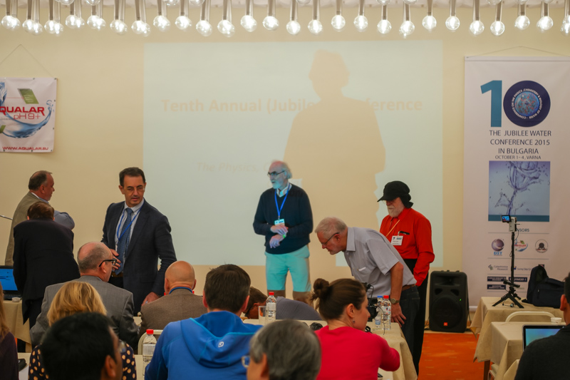
Do they masochistically invite criticism when it could easily be headed off at the pass by implementing the most basic standards of experimentation, measurement, verification and replication? Why do water scientists seem to, if not willfully, at least subconsciously, invite such abuse? Do they represent a kind of sub class of scientific submissive, eagerly awaiting the stiletto heel of establishment science pressing on their collective, uncoordinated and un-standardized crotches? Perhaps it is the open-ended nature of the subject matter itself, a subject matter that attracts non-conformists?

Varna-Bulgaria, October 1st, 2015

Well, just as ignorance of the law is no excuse, neither is ignorance of the rules governing establishment science, even if said rules are "rigged." It reminds me of the Groucho Marx quote "I refuse to join any club that would have me as a member." Water science needs to grow up if it is to be taken seriously. We've all seen the archetypal teenager demanding adult treatment merely by virtue of turning 18 when still unable to make his or her own bed. Watching water scientists demanding a seat at the grown-up scientific table is equally, if not more painful. Unhappy with the status quo? Why not establish your own peer-reviewed standards and journals? What's that you say? Invisible forces preventing you from establishing your own standards of inquiry? Could it be a "Vast Right Wing Conspiracy" (warning, Hillary already copyrighted that "one size fits all" excuse Clinton©).
Or could it be that you aren't really ready to grow up and agree upon common standards as a professional scientific body?

Shall I get you kids started on the path to adulthood so that your demands for equal treatment can be at least somewhat proportional to your willingness to assume responsibility for your work? How about establishing standards for categories of water, or better yet, standardized scales within standardized categories of water (de-ionized, deuterium content, alkalinity, acidity, ionic, colloidal, etc.)? How on Earth can the topic of replication even be broached without knowing the properties of the water itself?

Water science will never build a body of "reference-able" material without such standards. One cannot "scientifically" cite "similar" research unless one knows just how "similar" any two comparison waters really are.

With Gerald Pollack's discovery of Exclusion Zone water, there was great hope in what could/should have been a paradigm shift in our most fundamental understanding of water's long overlooked role in biology. Instead of a well-organized cocktail party among responsible adults, we have a Teenage free-for-all while Mom and Dad are out of town.

During the 10th annual Conference on the Physics, Chemistry and Biology of Water (organized by Mr. H₂O himself [Pollack]) a brave member of the peanut gallery raised the thorny adult issue of a common water standard/s. All one could hear were crickets chirping; I think a tumbleweed may even have rolled across the conference room floor. The awkward silence answered the question much more eloquently than words ever could. Despite all their bluster and posturing, the silence of the teenagers is what lawyers call "Estoppel by Acquiescence" (failure to respond is tacit admission of guilt).

